**Work case №3**

*Створив Михайленко Олексій*

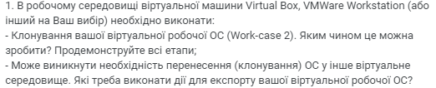

Here are the steps to **clone** and **export** your virtual operating system in both **VirtualBox** and **VMware Workstation** environments:

### 1. Cloning a Virtual Machine in VirtualBox

**Steps to clone in VirtualBox:**

1. **Open VirtualBox** and find the virtual machine (VM) you want to clone.
2. **Right-click** on the VM and select **"Clone"**.
3. A dialog will appear. Enter the name for the new virtual machine.
4. Choose the cloning option:
   * **Full clone**: A complete copy of the VM, including hard disks.
   * **Linked clone**: A smaller clone that shares resources with the original machine but depends on it.
5. Select whether to **clone the current state or all snapshots** (if available).
6. Click **"Next"** and then **"Clone"** to start the process.
7. Once finished, you will have a full copy of the original virtual machine.

### Cloning a VM in VMware Workstation

1. Open **VMware Workstation**.
2. Select the VM you want to clone.
3. **Right-click** the VM and go to **"Manage"**, then select **"Clone"**.
4. The **Clone Wizard** will open.
5. Choose whether to base the clone on the current state or a snapshot.
6. Select the type of clone:
   * **Full clone**: A complete copy of the VM.
   * **Linked clone**: A smaller, dependent copy that shares resources with the original VM.
7. Choose a name and storage location for the new VM.
8. Click **"Finish"** to complete the process.

### 2. Exporting a Virtual Machine for Migration

When moving a virtual machine to another virtual environment, you can **export** it in formats that are compatible across platforms. VirtualBox uses OVA/OVF, which is widely supported.

#### Exporting a Virtual Machine in VirtualBox:

1. Open **VirtualBox** and select the VM you want to export.
2. From the menu, select **File** → **Export Appliance**.
3. Choose the VM to be exported and click **Next**.
4. Select a location to save the file (either in **OVA** or **OVF** format).
5. Click **Next**, review the settings, and click **Export**.
6. The resulting OVA file can be imported into another virtual environment, such as VMware or a different instance of VirtualBox.

#### Exporting a Virtual Machine in VMware Workstation:

1. Open **VMware Workstation** and select the VM.
2. From the menu, go to **File** → **Export to OVF**.
3. Choose a folder to save the exported file and enter the file name.
4. Select **OVF** or **OVA** format.
5. Click **Export**.

Once exported, the OVA/OVF file can be imported into any environment that supports these formats via the **Import Appliance** feature or a similar function.

*Створив Трощинський Ярослав*

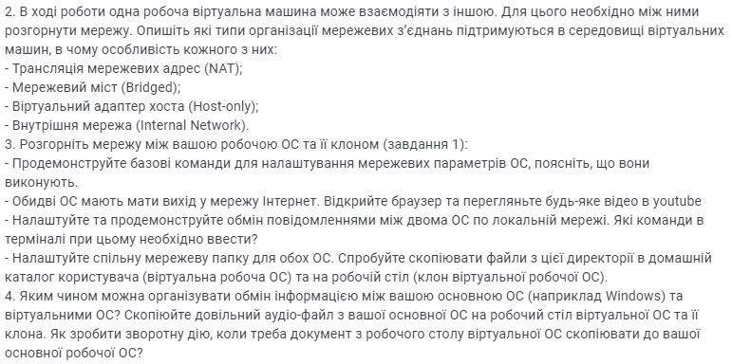

2. **In the course of work, one working virtual machine can interact with the other. To do this, you need to deploy the network between them. Describe what types of network connections are supported in the environment of virtual machines, what is the peculiarity of each of them:**

- broadcasting of network addresses (NAT);

- network bridge (bridged);

- host-only virtual adapter;

- Internal Network.

3. **Expand the network between your working OS and its clone (Task 1):**

- Demonstrate basic commands to set up network OS settings, explain what they are doing.

- Both OSs should have an internet. Open your browser and see any video on YouTube

- Set up and demonstrate messages between two OS on a local network. What commands in the terminal need to be introduced?

- Adjust the common network folder for both OS. Try copying the files from this directory to the user's home directory (virtual work OS) and on the desktop (virtual working OS clone).

4. **How can you organize information exchange between your basic OS (eg Windows) and virtual OS? Copy an arbitrary audio file from your main OS to the virtual OS desktop and its clone. How to do the reverse action when you need a document from the virtual desktop to copy to your main working OS?**

2. To differences between all the types of connection I found a perfect table from [Virtualbox.org](https://www.virtualbox.org/manual/ch06.html#nichardware)

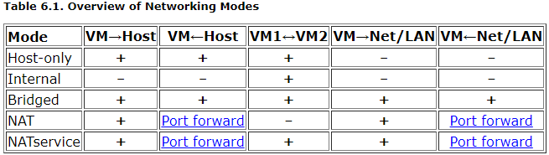

Bridged connection is really good for amateur use of virtual machines, because it is

the fastest connection among this, but for our situation will be suitable a combo of NAT and Host-only as second adapter device.

3. To get IP address we need to use command “ifconfig”, and we will get this result where I underlined needed info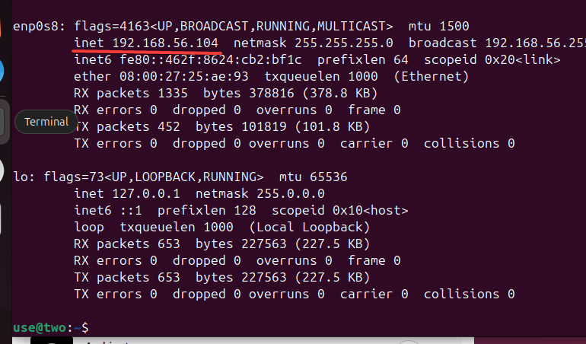

After that I opened youtube on both VMs

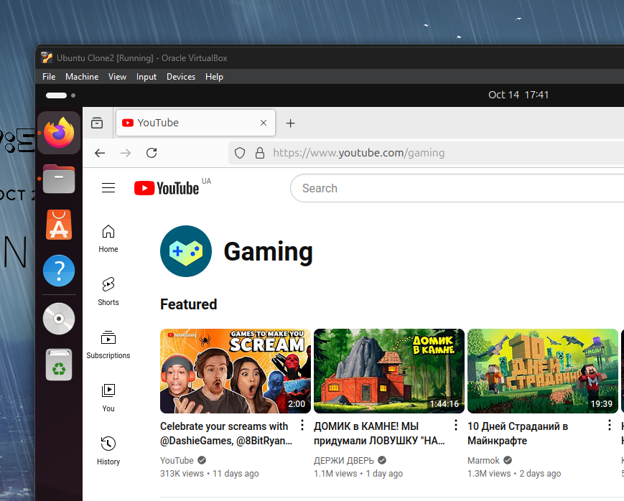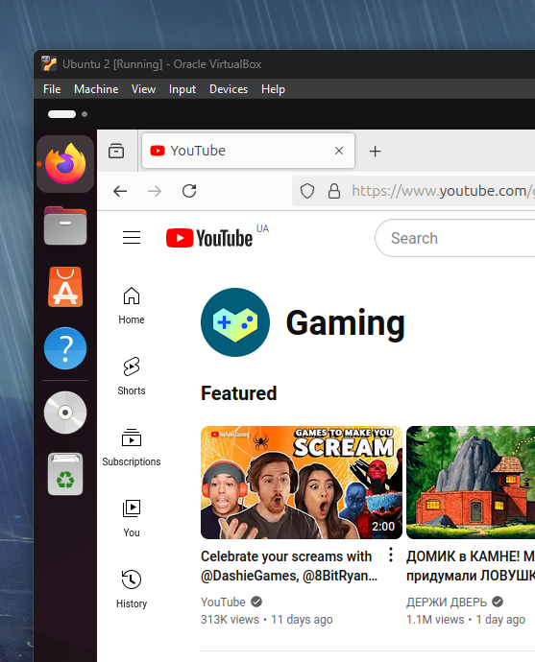

To do a transferring of messages between VMs I used commands

nc -l -p “12345” – on the first VM

nc 192.168.56.104 12345 – on the second

From now on if you type something on one of the two VMs you can see the message on both of them

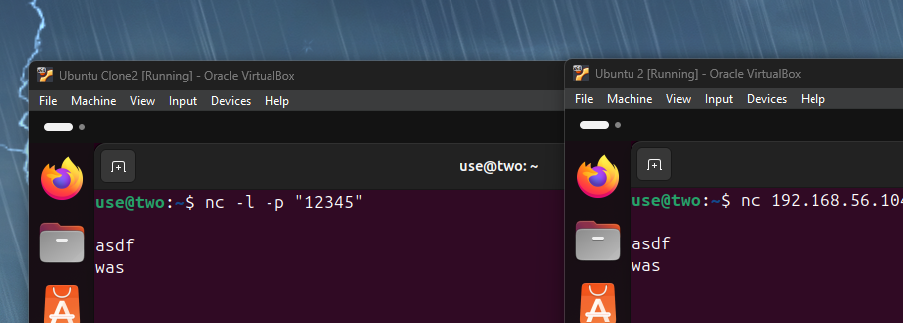

To make a Shared folder I created a folder 456

After that I changed its sharing properties to “Everyone Read/Write”, and chose this folder for both of VMs as sharing one with “auto-mounting” box checked. Now we can access this folder from any of VMs using this command

sudo open /media/sf_456/

To transfer files we just need to throw something in this folder and it will be accessible from any OS, using this method we can even share files between VMs.

4. To make a file transfer from the main OS to VM we just need to move files to the shared folder, and it will be accessible on the virtual OS, and it also works vice versa. On linux we do not have a media player, but we do have a app center, so installing one won't be a problem. Personally, I chose a VLC media player, from my experiments we could have even easily downloaded it without app center, using command

sudo apt install vlc

And to transfer an audio we could just install it on main OS and transfer it to the shared folder, so we could listen to it on any of our VMs.

*Б.Когут*

**Conclusion**:

In this work, we explored essential steps to clone and export virtual machines in both VirtualBox and VMware Workstation. Understanding the distinctions between full and linked clones, as well as the process of exporting VMs in OVA/OVF formats, is crucial for seamless migration between environments. Additionally, the configuration of network connections between virtual machines, such as NAT, bridged, and host-only adapters, was demonstrated. By setting up shared folders and utilizing basic networking commands, we facilitated communication and file transfers between virtual machines, thus enhancing the overall virtualization environment. These tasks prove the flexibility and power of virtual machines in replicating and managing systems efficiently.